Monitor de vía

Installation manual

 | Author | Date
Creation | Dvera | 30/05/2025
Last Revision | Dvera | 23/09/2026

DOCUMENT REVISIONS

Revision | Date | Author | Pages | Modifications
1 | 30/05/2025 | DVERA | All | Initial version.
2 | 22/09/2026 | DVERA | All | Installation with the installer package (ADB over the network), first start permissions, uninstall and troubleshooting. Application renamed to Monitor de vía.
3 | 23/09/2026 | DVERA | All | Installer messages translated to English (Y/N confirmation). Console screenshots updated.

Content

1 Description 4
1.1 Installer package contents 4
1.2 Requirements 4
2 Preparing the display 5
3 Installation 6
3.1 New installation 6
3.2 First start and permissions 6
3.3 Set the application as default home 7
3.4 Install update 8
3.5 Uninstall 8
3.6 Troubleshooting 9
4 Modifying the config 10

Description
This document describes how to install, update and uninstall the Monitor de vía application on the 55'' display model DG03-A1W55 using the installer package supplied with each release.
The installer package installs the application over the local network using ADB (Android Debug Bridge), so it is no longer necessary to copy the APK file to the display by FTP and install it manually from the file manager.
The FTP server is built into the Monitor de vía application, so no additional FTP Server application is required.
Note: The display must have the WiFi switched on and connected to the same network as the computer used for the installation.
Note: The screenshots of this manual were taken on a test Android device. The screens of the Monitor de vía display may look slightly different, but the steps are the same.

Installer package contents
File | Description
installer.bat | Installs the Monitor de vía application on a display where it is not installed yet.
update.bat | Installs a new version over the current one, keeping the application data and settings.
uninstall.bat | Removes the Monitor de vía application from the display.
dashboard-release.apk | Monitor de vía application installer used by installer.bat and update.bat.
resources\ | ADB tools used by the scripts (adb.exe, AdbWinApi.dll and AdbWinUsbApi.dll). Do not modify or remove them.

Note: Keep all the files in the same folder. The scripts look for the APK and the resources folder next to themselves.

Requirements
- A Windows computer connected to the same network as the display.
- The display with the WiFi switched on and connected to that network.
- The installer package copied to a local folder of the computer.
- The display IP address.
- ADB over the network enabled on the display (see section 2).

Preparing the display
The scripts connect to the display through the network on port 5555. This connection must be enabled once from a computer connected to the display with a USB cable:
- On the display, check that the WiFi is switched on and connected to the same network as the computer.
- On the display, open Settings > About and tap Build number seven times to enable the Developer options.
- Open Settings > System > Developer options and enable USB debugging.
- Connect the display to the computer with a USB cable. When the display asks Allow USB debugging?, select Always allow from this computer and OK.
- On the computer, open a command window (cmd) in the installer package folder and run the following commands:
resources\adb.exe devices
resources\adb.exe tcpip 5555
The first command must list the display with the status device; the second one enables the network connection on port 5555 (it may show no message).
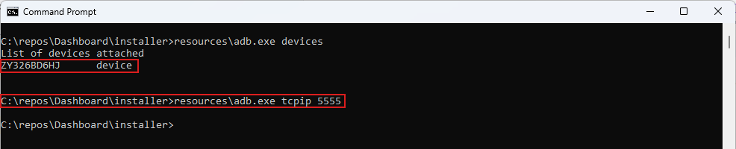
Figure 1. ADB over the network enabled on port 5555.
- Check the IP address of the display in the WiFi settings (Settings > Network > Wi-Fi, selecting the connected network) or in Settings > About > Status (in this manual, 192.168.101.100).
- Disconnect the USB cable.
Note: Disconnect the USB cable before running the scripts. If the display is connected by USB and by the network at the same time, the installation fails with the error "more than one device/emulator".
Note: ADB over the network is disabled when the display is restarted. After a restart, repeat this section before running the scripts.

Installation

New installation
- Double-click installer.bat.
- When the script asks for the connection address, type the display IP address followed by :5555 (for example, 192.168.101.100:5555) and press Enter.
- Wait until the message Installation completed successfully appears and press any key to close the window.
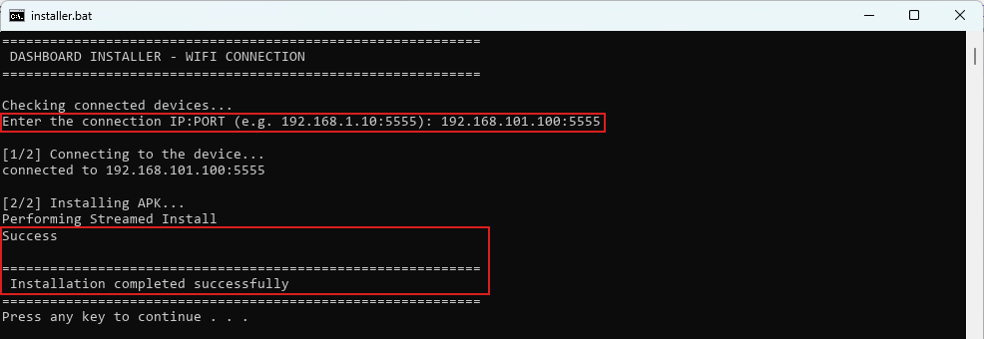
Figure 2. Installation completed successfully.
Note: If the display is already connected (for example, after a previous script), the script shows the message "Device found" and asks "Use this device? (Y/N)". Type Y to use it or N to type a different address.

First start and permissions
The script does not open the application. On the first start, the application requests the permissions it needs to work:
- Press the Home key on the remote control and select the Monitor de vía application in the list (the display shows it as "Dashboard app").
- The application starts and opens the Modify system settings screen. Enable Allow modifying system settings (needed to control the screen brightness) and press Back.
- Select ALLOW in the two permission requests (phone and files).
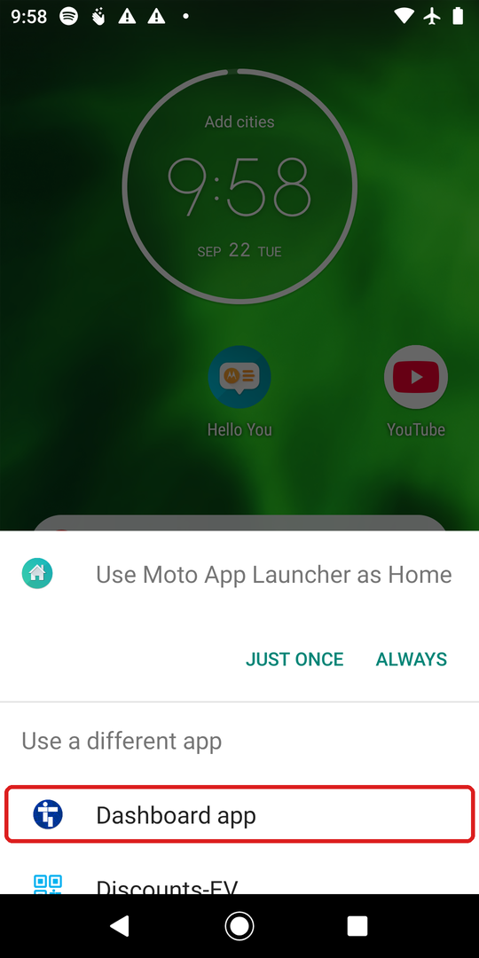  Figure 3. Select the application. | 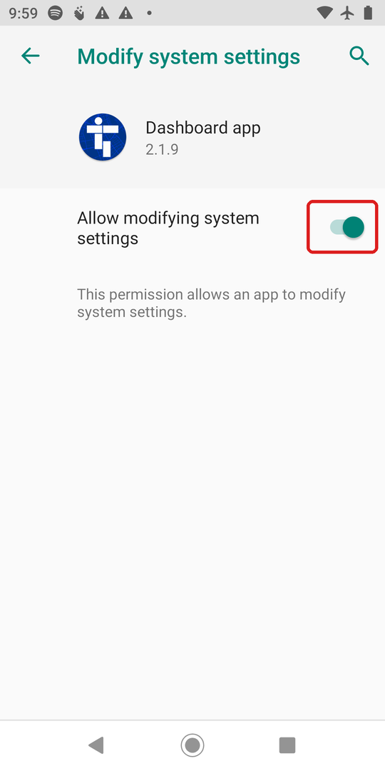  Figure 4. Allow modifying system settings. | 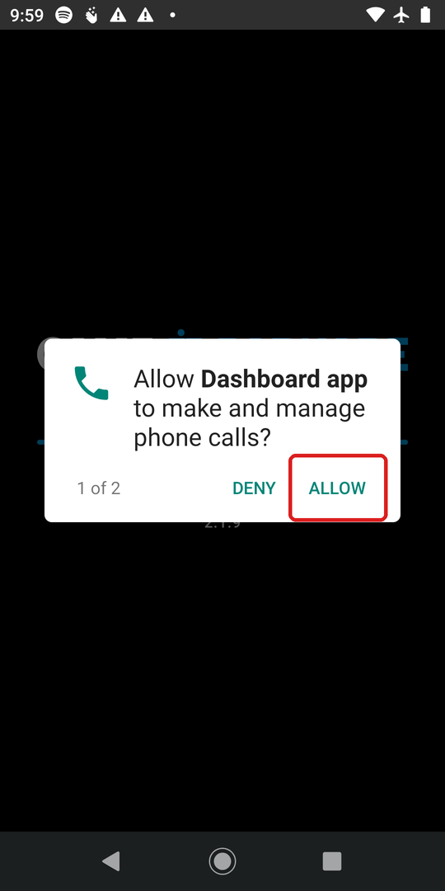  Figure 5. Allow the phone permission. | 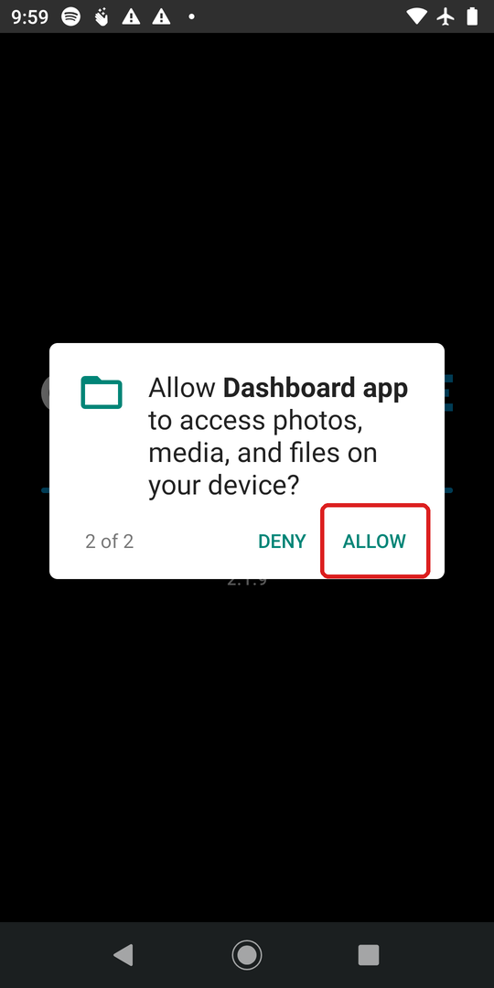  Figure 6. Allow the files permission.

Once the permissions are granted, the application shows the main screen and creates the folder "Documents/Dashboard" in the internal storage, where the configuration files are stored (see section 4).

Set the application as default home
To start the Monitor de vía application automatically when the display is switched on:
- Press the Home key on the remote control again.
- In the window that asks which application to use as Home, select ALWAYS.
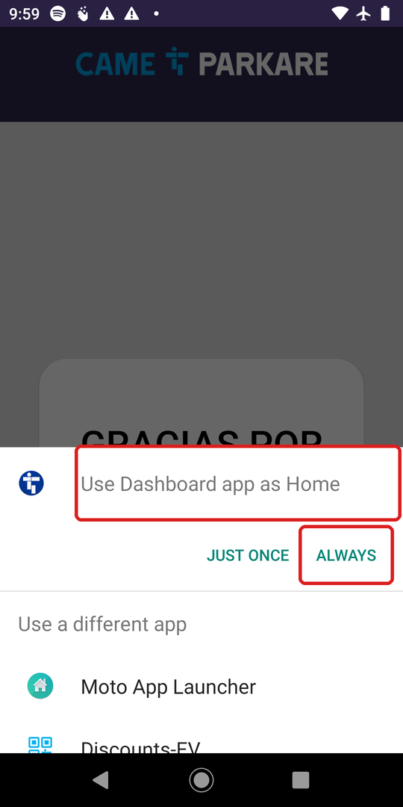
Figure 7. Set the application as default home.
From now on, the Home key and the display start-up open the Monitor de vía application. The permissions and the default home selection are only requested after a new installation; they are kept after an update.

Install update
To install a new version on a display that already has the Monitor de vía application installed:
- Copy the new installer package to the computer (it includes the new dashboard-release.apk).
- Double-click update.bat and type the display address (192.168.101.100:5555), or type Y if the display is already connected.
- Wait until the message Update completed successfully appears and press any key to close the window.
- The application closes during the update. Press the Home key on the remote control to open the new version.
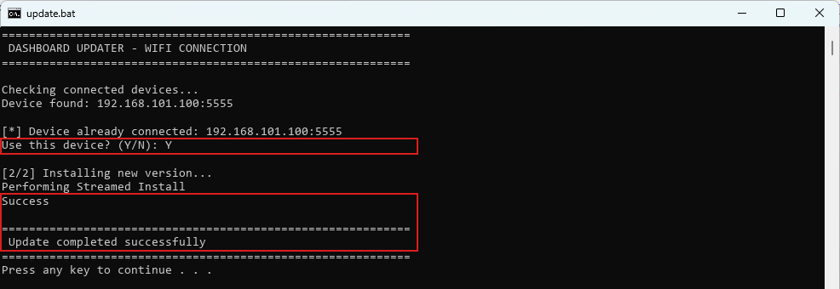
Figure 8. Update completed successfully.
Note: The update keeps the permissions, the default home selection and the configuration.
Note: If installer.bat is run on a display that already has the application installed, it also updates it in the same way.

Uninstall
- Double-click uninstall.bat and type the display address (192.168.101.100:5555), or type Y if the display is already connected.
- Wait until the message Uninstall completed successfully appears and press any key to close the window.
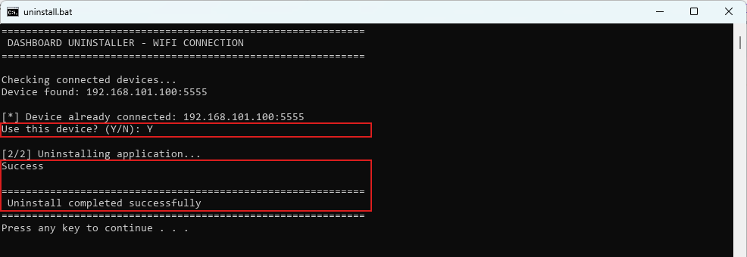
Figure 9. Uninstall completed successfully.
Note: The configuration folder "Documents/Dashboard" is not removed, so it is used again if the application is reinstalled.

Troubleshooting
Message | Cause and solution
ERROR connecting. Check the IP address and port. | The display is not reachable. Check that the WiFi of the display is switched on, the IP address, that the port is 5555, that the computer and the display are on the same network and that ADB over the network is enabled (after a restart, repeat section 2).
failed to connect / unauthorized | The display has not authorised the computer. Repeat section 2 and accept the "Allow USB debugging?" message on the display.
ERROR installing the APK. (more than one device/emulator) | The display is connected by USB and by the network at the same time. Disconnect the USB cable and run the script again.
ERROR uninstalling. Check that the application is installed. | The Monitor de vía application is not installed on the display.

Modifying the config
- The configuration can be modified with the web configurator: from a browser on a computer connected to the same network, open the address of the display with the port 8080 (for example, http://192.168.101.100:8080).
- The configuration files can also be modified directly in the folder "Documents/Dashboard/config/" of the display. On Android 9 they can be accessed from the file manager; on Android 11 or higher, access the folder through the FTP server on port 2122.
Note: After changing the configuration files, close and reopen the Monitor de vía application to apply the changes.

